**2.**

**(b) Matlab code:**

indexi=1;

indexj=1;

output=zeros(51);

for i=-5:0.2:5

for j=-5:0.2:5

a=0.3*i-0.1*j+0.5; %equations

b=1.716*tanh(2/3*a); %equations

c=-0.4*i+1*j-0.5; %equations

d=1.716*tanh(2/3*c); %equations

e=-2*b+0.5*d+1; %equations

f=1.716*tanh(2/3*e); %equations

output(indexi,indexj)=f;

indexj=indexj+1;

if f>=0

scatter(i,j,'x','g');

hold on;

else

scatter(i,j,'o','r');

hold on;

end

end

indexi=indexi+1;

indexj=1;

end

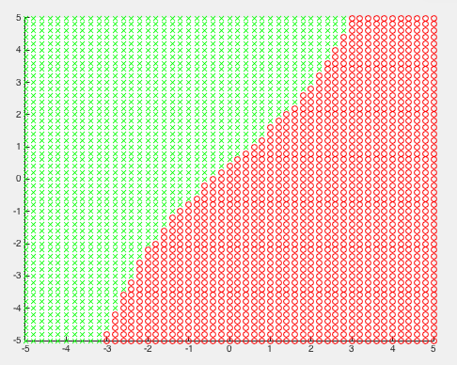

**(c)**

**(d)Matlab code:**

x1=2.2;

x2=-3.2;

a=0.3*x1-0.1*x2+0.5; %equations

b=1.716*tanh(2/3*a); %equations

c=-0.4*x1+1*x2-0.5; %equations

d=1.716*tanh(2/3*c); %equations

e=-2*b+0.5*d+1; %equations

f=1.716*tanh(2/3*e); %equations

y1=f %display output y

x3=-3.2;

x4=2.2;

a=0.3*x3-0.1*x4+0.5; %equations

b=1.716*tanh(2/3*a); %equations

c=-0.4*x3+1*x4-0.5; %equations

d=1.716*tanh(2/3*c); %equations

e=-2*b+0.5*d+1; %equations

f=1.716*tanh(2/3*e); %equations

y2=f %display output y

answer:

the output of (x1,x2)=(2.2,-3.2)= -1.5897

the output of (x1,x2)=(-3.2,2.2)= 1.6735

**(e)**

**repeat(b)**

Matlab code:

indexi=1;

indexj=1;

output=zeros(51);

for i=-5:0.2:5

for j=-5:0.2:5

a=-0.5*i+1.5*j-1; %equations

b=1.716*tanh(2/3*a); %equations

c=1.5*i-0.5*j+1; %equations

d=1.716*tanh(2/3*c); %equations

e=-1*b+1*d+0.5; %equations

f=1.716*tanh(2/3*e); %equations

output(indexi,indexj)=f;

indexj=indexj+1;

if f>=0

scatter(i,j,'x','g');

hold on;

else

scatter(i,j,'o','r');

hold on;

end

end

indexi=indexi+1;

indexj=1;

end

scatter(x,y,'x','g');

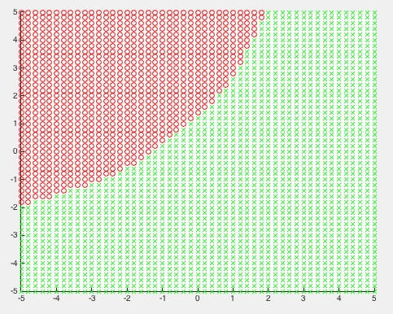

**repeat(c)**

**repeat (d)**

**Matlab code:**

x1=2.2;

x2=-3.2;

x3=-3.2;

x4=2.2;

a=-0.5*x1+1.5*x2-1; %equations

b=1.716*tanh(2/3*a); %equations

c=1.5*x1-0.5*x2+1; %equations

d=1.716*tanh(2/3*c); %equations

e=-1*b+1*d+0.5; %equations

f=1.716*tanh(2/3*e); %equations

y1=f %display output y

a=-0.5*x3+1.5*x4-1; %equations

b=1.716*tanh(2/3*a); %equations

c=1.5*x3-0.5*x4+1; %equations

d=1.716*tanh(2/3*c); %equations

e=-1*b+1*d+0.5; %equations

f=1.716*tanh(2/3*e); %equations

y2=f %display output y

answer:

the output of (x1,x2)=(2.2,-3.2)= 1.6979

the output of (x1,x2)=(-3.2,2.2)= -1.6464

extra credit:

the final plot has to be exactly the combination of two plot above. So I multiplied two outputs from two networks above and check their results. If the result larger than 0,then plot a “x”, meaning I got positive output, and plot a ”o” otherwise.

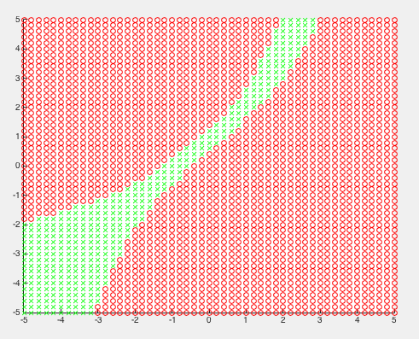

4.

(a)

In my matlab code, I extracted the data from Netlab first. Then I split the data into two parts, one of which is training data and the other one is validation data. I put the training data into “netopt” function. Then I put training data, validation data and test data, which is also extracted from Netlab, into “mlpfwd” function to calculate all kinds of error.

What’s more, the cross-validation method I used is “holdout”, meaning that I hold part of the data as validation data, instead of training all.

(b)

parameters:

net: structure

a: training data

b: validation data

y: output

output: transformed output(0~9)

(c)

**training error:** difference between training labels and the training output from training data

**validation error:** difference between the outputs of networks using training data and validation data as inputs.

**Test error:** difference between the outputs of networks using training data and test data as inputs.

First of all, for training error, using less training sample I got good performance without error. However, when increasing number of training samples, I got some training error. I think the reason was, using only 50 epochs is not enough to update all the weights to get the result correct if using too many samples. I think it will be improved with higher epochs or higher learning rate.

|  |  |  |  |  |
| --- | --- | --- | --- | --- |
| Training samples  Hidden units | 100 | 1000 | 10000 | 60000 |
| 100 | 0% | 0% | 0.34% | 4.05% |
| 500 | 0% | 0% | 3.08% | 4.62% |
| 1000 | 0% | 0% | 4.89% | 6.83% |

**Training error(%), epochs=50**

For validation error and test error, the more training samples I used, the lower error rate I got. And I think in this question, the number of hidden units didn’t affect the error rate too much.

What’s more, there is high error rate when I used less training sample with high hidden unit. I think that was because of overfitting. And the overfitting problem came from the fact that I used too many hidden units to train relatively less samples. So when I increased the training samples, the error became lower.

|  |  |  |  |  |
| --- | --- | --- | --- | --- |
| Training samples  Hidden units | 100 | 1000 | 10000 | 60000 |
| 100 | 31.38% | 12.12% | 5.74% |  |
| 500 | 31.52% | 13.04% | 6.52% |  |
| 1000 | 31.4% | 14.15% | 7.99% |  |

**validation error(%), epochs=50**

|  |  |  |  |  |
| --- | --- | --- | --- | --- |
| Training samples  Hidden units | 100 | 1000 | 10000 | 60000 |
| 100 | 31.8% | 11.7% | 5.77% | 4.46% |
| 500 | 32.29% | 12.47% | 6.27% | 4.84% |
| 1000 | 31.64% | 13.68% | 7.7% | 6.97% |

**test error(%), epochs=50**

It was obvious that using more training samples, epochs or hidden units takes more time to train, so we have to make a trade-off between time and accuracy.

Finally, I chose the network with 30000 training samples, 200 epochs and 500 hidden units as my best network.

|  |  |  |  |
| --- | --- | --- | --- |
| Error type  Epochs | Training error | Validation error | Test error |
| 50 | 4.51% | 5.44% | 4.99% |
| 100 | 0.07% | 2.68% | 2.42% |
| 200 | 0% | 2.44% | 2.27% |

**Training sample=30000, hidden units=500**

(d)

misclassified:

9th: 248th :

5🡪6 4🡪6

correctly classified:

